

press release
(English translation)

IEG: MIR - MULTIMEDIA INTEGRATION EXPO 2025 SHAPES THE FUTURE OF
AUDIO VISUAL TECHNOLOGY AND ENTERTAINMENT

- From 23 to 25 March 2025 Rimini Expo Centre will host the event unveiling the solutions revolutionising the audio, video, lighting and broadcast technology industry for concerts, shows and events
- This year's new feature is Sound Stage Outdoor, an outdoor area dedicated to live demos of audio systems

Rimini, 28 November 2024 – MIR - Multimedia Integration Expo, organised by Italian Exhibition Group (IEG), is priming its 2025 edition, running from 23 to 25 March in Rimini Expo Centre and which will mark – as the name suggests – the evolution of the event, which has gone beyond simple live entertainment. The new payoff, Multimedia Integration Expo, represents the variety of integrated technologies in the audiovisual industry, including solutions for corporate, education, retail, highlighting MIR’s multidisciplinary approach and making it a cornerstone for innovation and technological convergence in multiple sectors.
Following the story line of "The Future of Audiovisual and Entertainment Technology", MIR will give visitors a sneak peek at emerging technological solutions destined to redefine and shape the future of the entire industry.

A unique experience on the European scene
MIR outshines as a pivotal event for companies, professionals and workers in the systems integrator industry of audio, video, lighting and broadcast. An event that has gradually evolved into an interactive and immersive space to showcase the most advanced technologies, integrated solutions and share them with the entire supply chain, catering to diverse different professional needs. With an increasingly dynamic and innovation-oriented format, MIR has constantly expanded its offering, consolidating itself as a reference hub for both Italy and European countries.

Four halls dedicated to audiovisual innovation
The 2025 edition of the event promises to be even bigger and bursting with new features. To accommodate the expansion, this year the exhibition area will occupy four halls, providing an immersive and complete experience for all industry professionals.
These halls will unveil the latest trends in audio, video, broadcast, lighting and systems integrators. Visitors can discover the most innovative solutions for live events, concerts, company meetings... There will also be a special area dedicated to Live Production, with practical demos and workshops led by some of the industry’s top experts. Another section will focus on systems integrators, presenting cutting-edge solutions to optimise the audiovisual experience in professional contexts such as companies, hotels, museums, shops and schools. Customised and high-quality solutions, as well as a unique opportunity to update and network will be offered in collaboration with SIEC.

Live You Play: live experiences and Sound Stage Outdoor
One of the firm favourites of the event is Live You Play. The area will extend over three additional halls where the public can try out audio and video technologies in a realistic and engaging scenario, experiencing the effect of lights, sounds and audiovisual installations live in a 100% immersive configuration.

Live You Play will also feature the new entry for 2025 - Sound Stage Outdoor, an outdoor area dedicated to live demos of audio systems, without the acoustic restrictions of the internal halls. A unique experience once again aimed at the professional public to assess the performance of the solutions provided by the industry’s main players in real conditions.

MIR Club: where DJs and Club Culture merge
The 2024 edition was a huge success for MIR Club, the space dedicated to DJs and Club Culture, proving the public's interest in a place capable of hosting the industry’s leading brands and at the same time offering visitors a vibrant environment, full of connections, inspirations and new discoveries. For this reason, MIR Club will be back in 2025, supported once again by DJ Mag Italia, the leading magazine for the electronic music scene. This area will have an exclusive programme of events, meetings and demos featuring top names in club culture and DJing, as well as an exhibition of the latest technologies in musical entertainment and the DJ Experience area.

Training and masterclasses: keep growing
MIR 2025 will once again focus on training, with boosted, qualified training in the form of high-level Masterclasses designed for Live Production and Lighting technicians. What’s more, thanks to the collaboration with SIEC, there will be an advanced course (which also includes training credits) for architects and designers focusing on fundamental themes regarding the new frontiers of technological and integrated applications.
A deep dive into this topic will also be held in a conference organised in collaboration with the publishing house, Soiel International.

Keep up with all the news at https://www.mirtechexpo.com/

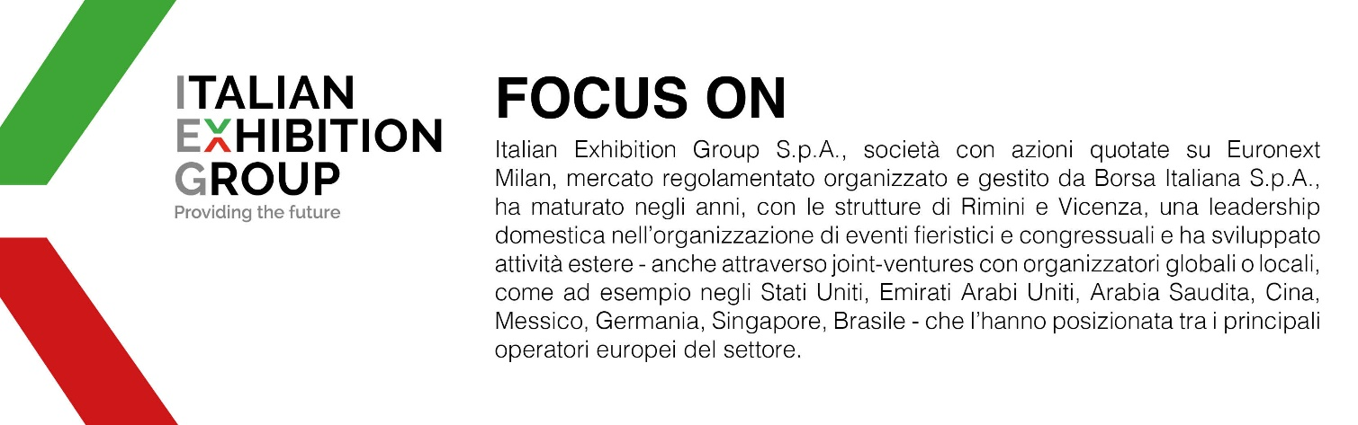

ABOUT MIR 2025
Organizer: Italian Exhibition Group S.p.A.; Recurrence: annual; Edition: 8th, from 23 to 25 March 2025; Open to: professional operators and the general public; website: www.mirtechexpo.com

ITALIAN EXHIBITION GROUP PRESS CONTACTS
head of media relations & corporate communication: Elisabetta Vitali; press office manager: Marco Forcellini, Pier Francesco Bellini; press office specialist: Luca Paganin, Mirko Malgieri

This press release contains forecast elements and estimates that reflect the management´s current opinions (´forward-looking statements´), particularly regarding future management performance, realization of investments, cash flow trends and the evolution of the financial structure. For their very nature, forward-looking statements have a component of risk and uncertainty, as they depend on the occurrence of future events. The effective results may differ (even significantly) from those announced, due to numerous factors, including, only by way of example: food service market and tourist flow trends in Italy, gold and jewellery market trends, green economy market trends; the evolution of raw material prices; general macroeconomic conditions; geopolitical factors and evolutions in the legislative framework. Moreover, the information contained in this release, does not claim to be complete, and has not been verified by independent third parties. Forecasts, estimates and objectives contained herein are based on the information available to the Company as at the date of this release.

